Ex No: 7:

Secure Network Architecture
Aim :
To understand the fundamentals of secure network architecture and how security zones, segmentation, and policies are used to protect systems.
To learn how to design and analyze network security controls like VLANs, ACLs, and traffic filtering to prevent cyber threats.

Procedure :
- Log in to the TryHackMe platform and open the Intro to Security Architecture room.
- Study the introduction and basic concepts of secure network architecture and its importance.
- Perform tasks related to network segmentation, including VLANs and trunk configurations.
- Analyze different network zones (External, DMZ, Trusted, Restricted) and understand their roles in security design.
- Evaluate network security policies such as ACLs and filtering rules to determine whether traffic is allowed or blocked

Task 1 : Introduction

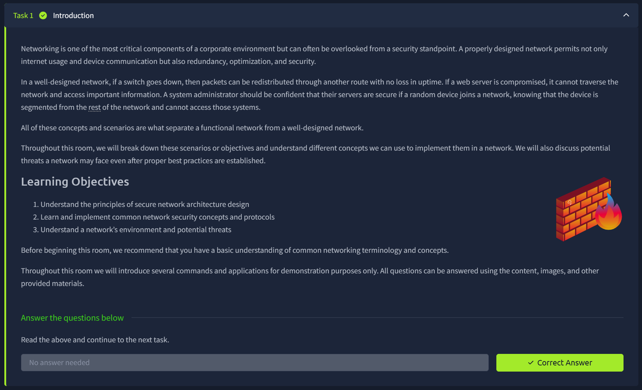

Task 2: Network Segmentation
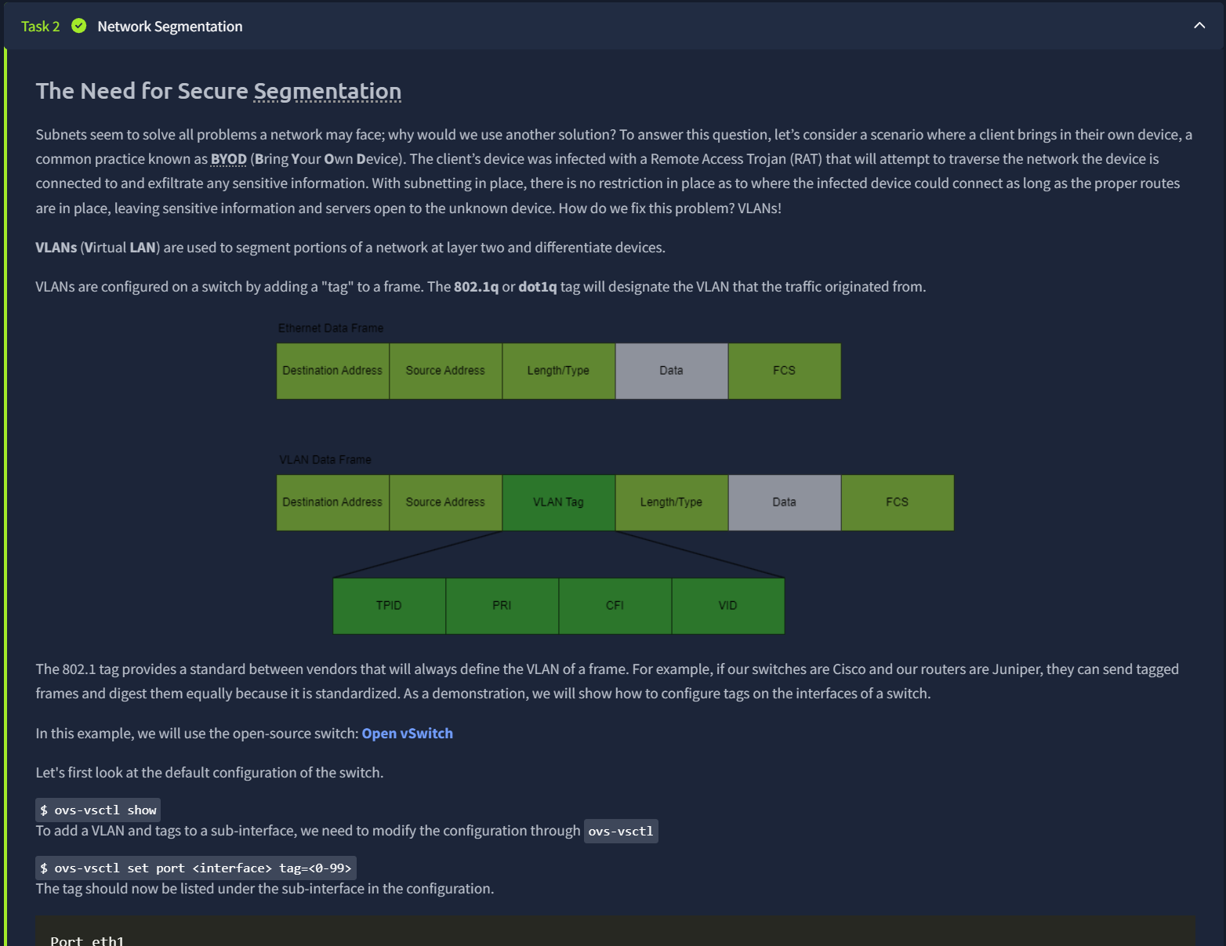
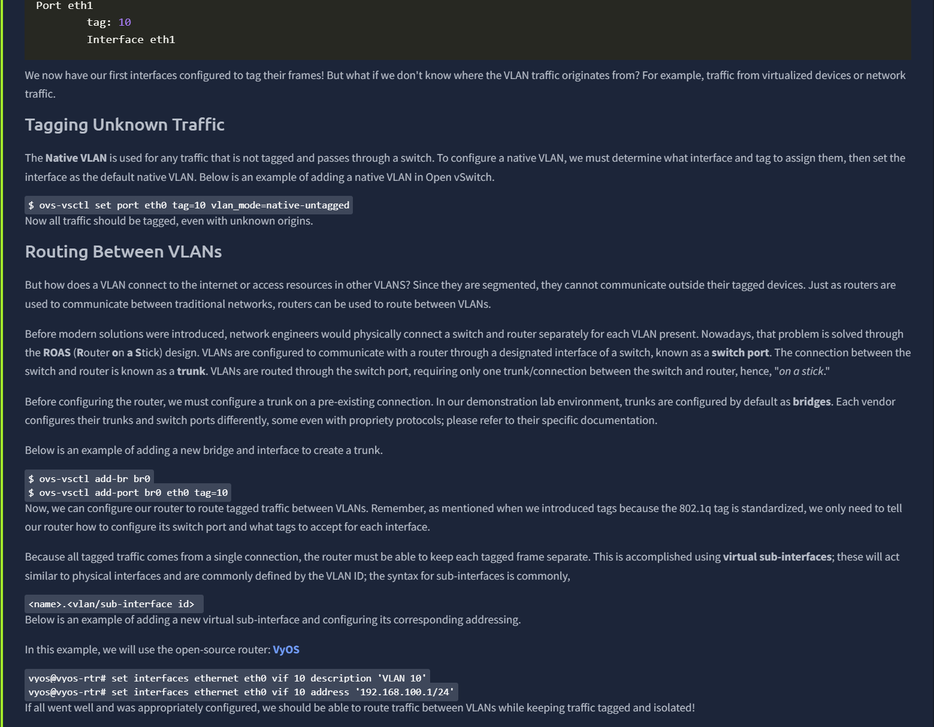
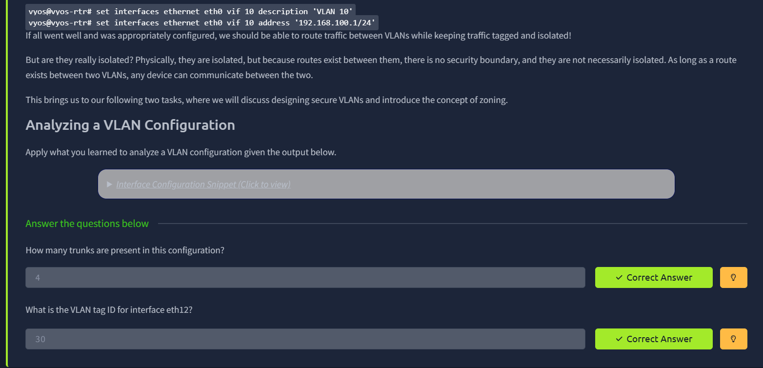
Task 3: Common Secure Network Architecture
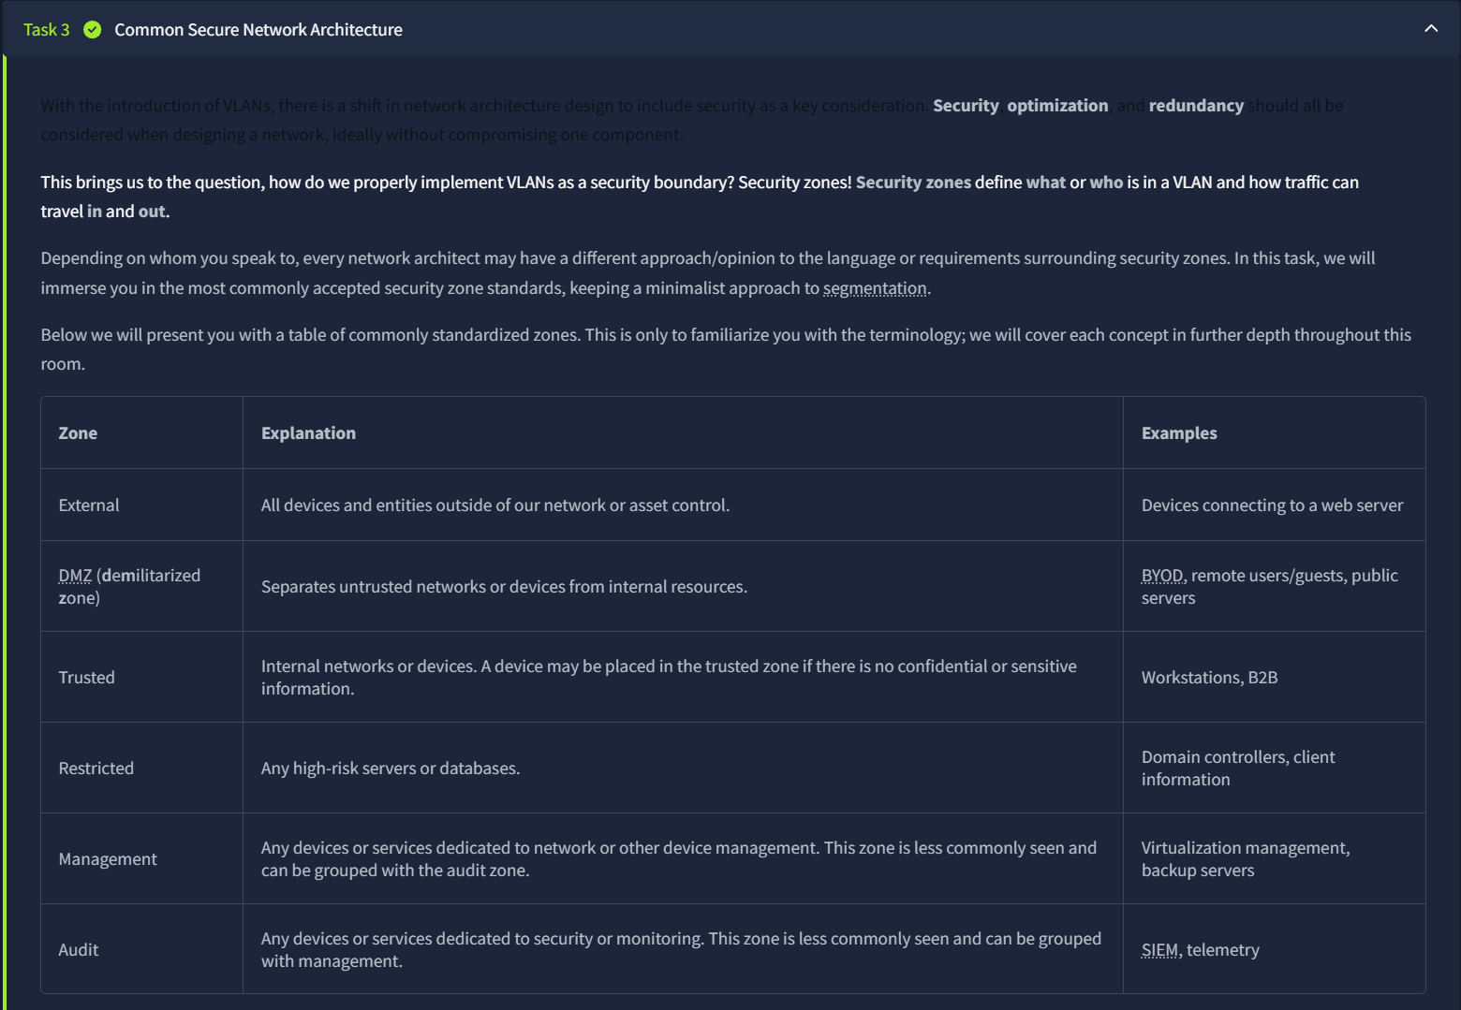
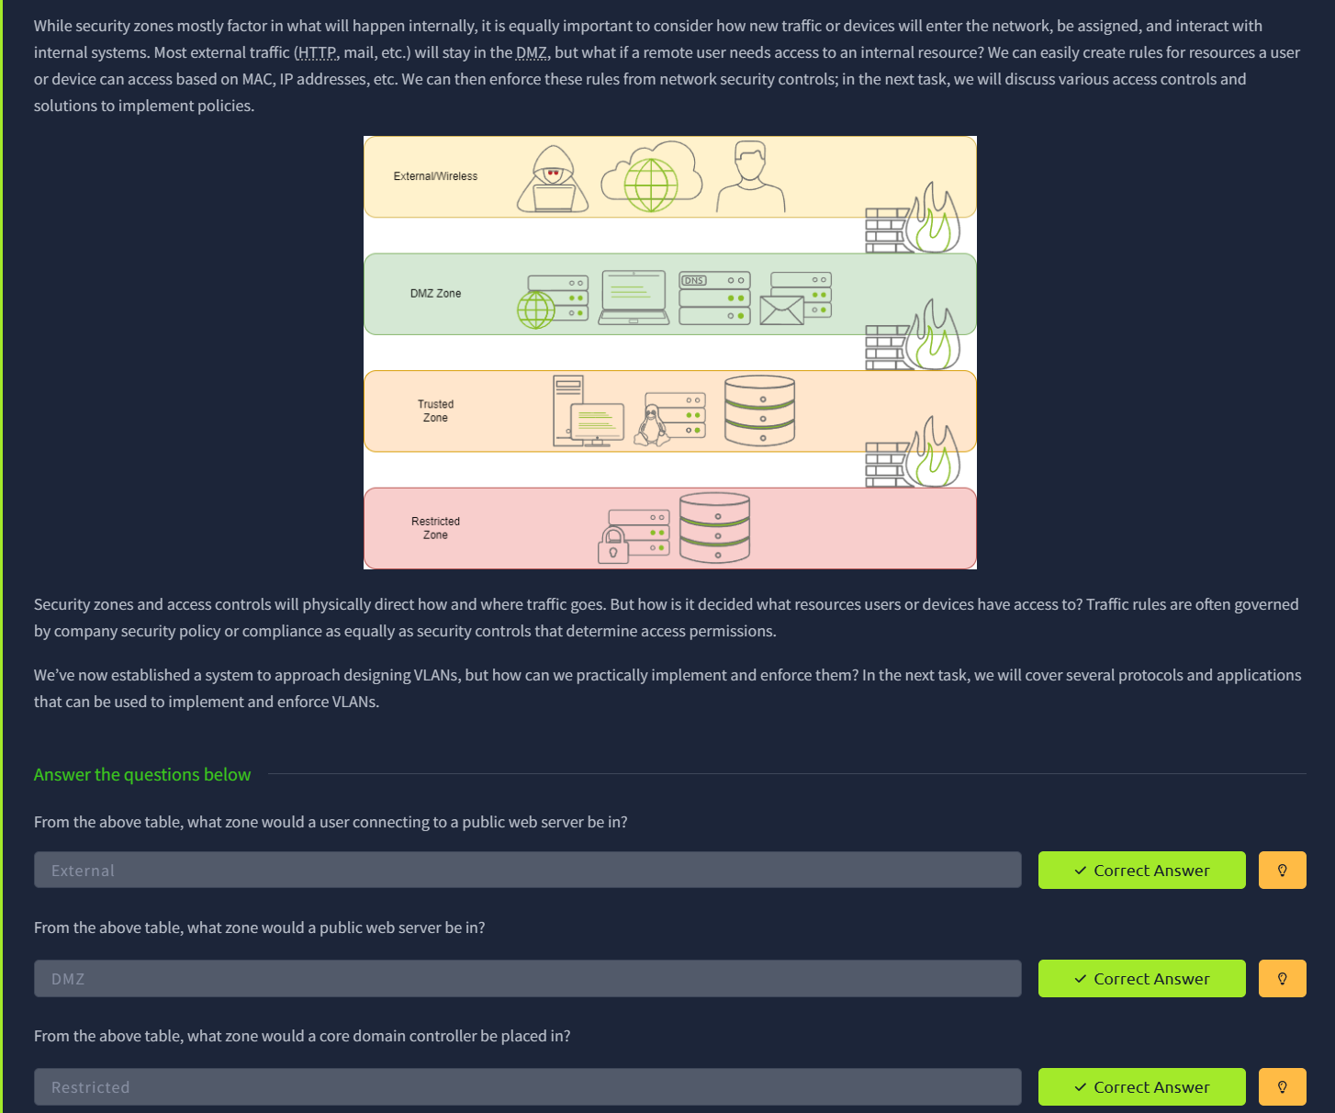
﻿Task 4: Network Security Policies and Controls
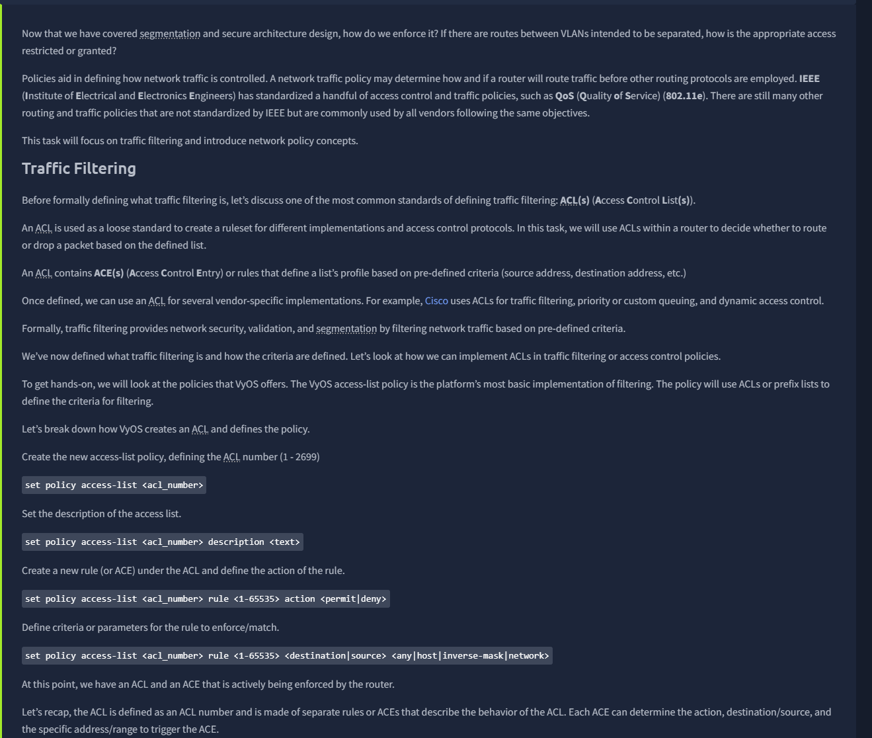
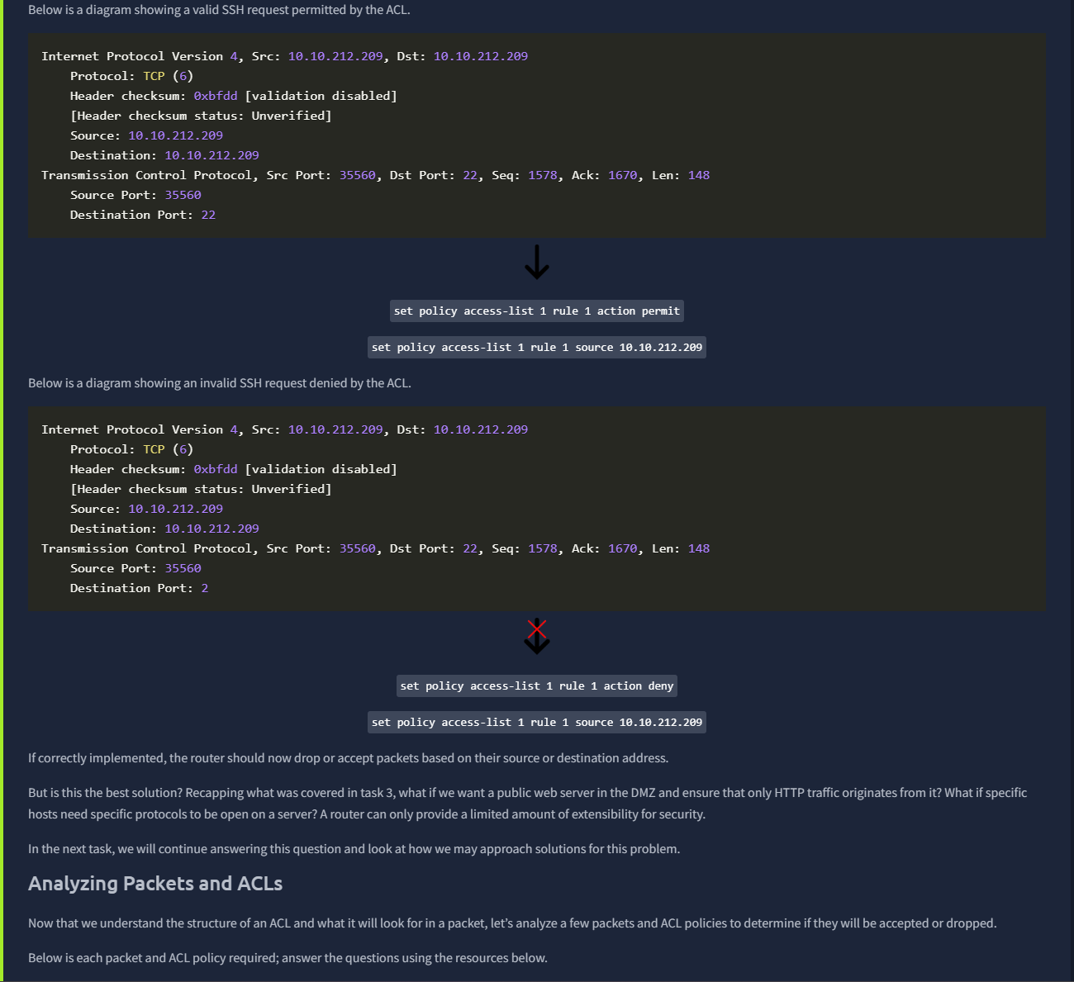
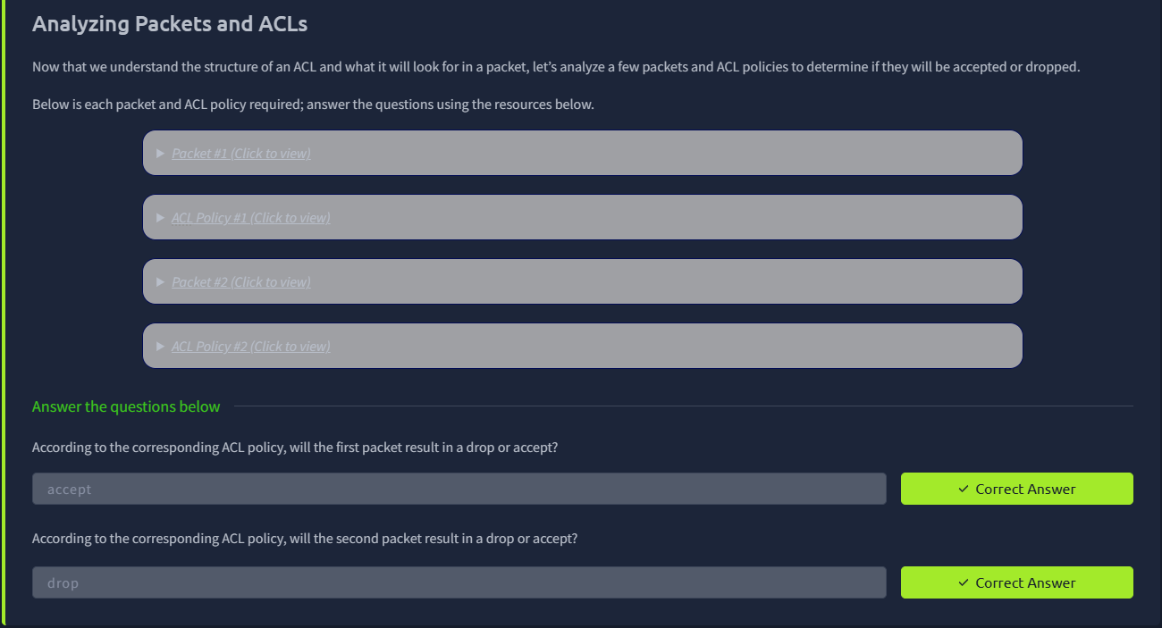

Task 5: Zone-Pair Policies and Filtering
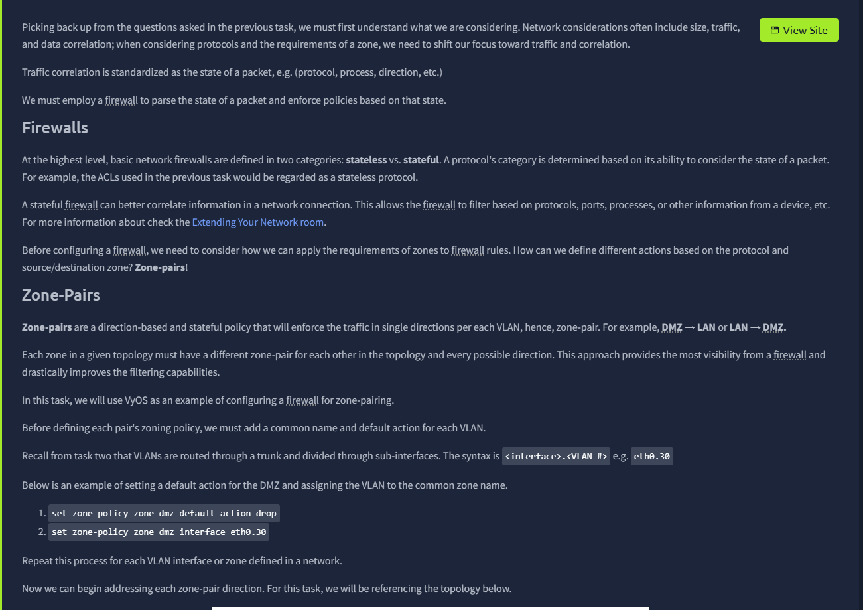
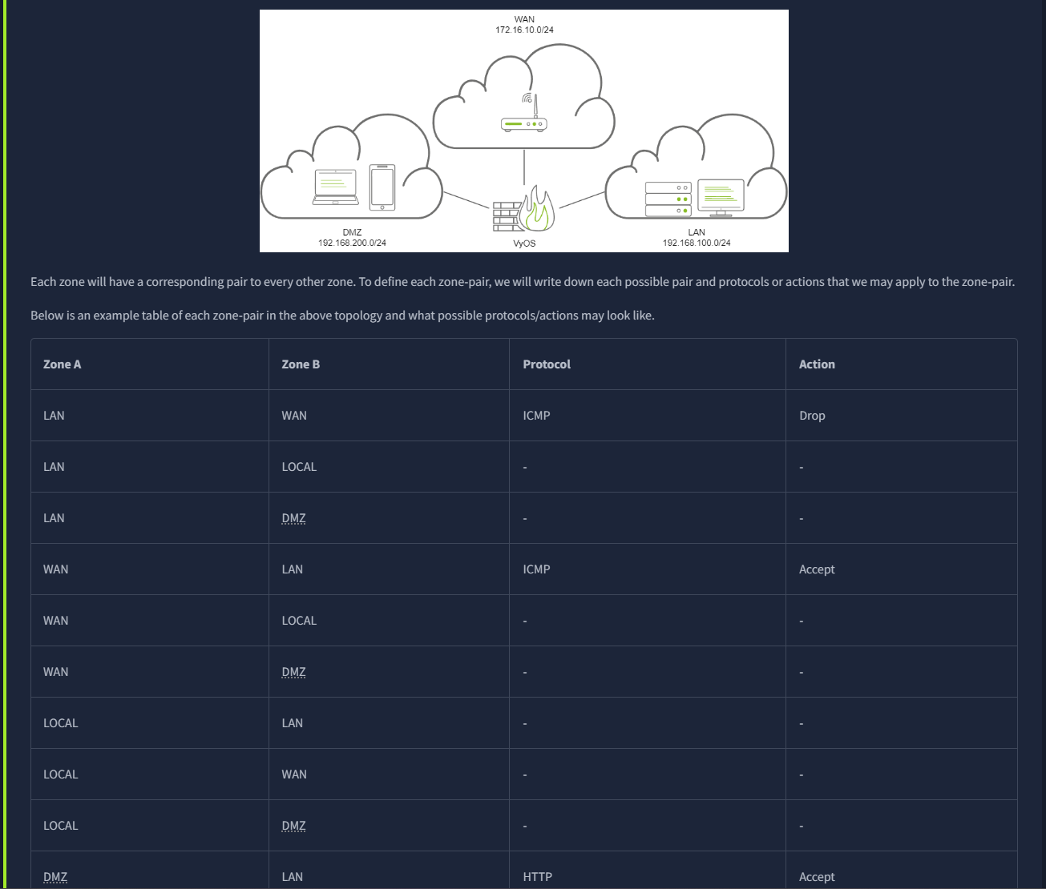
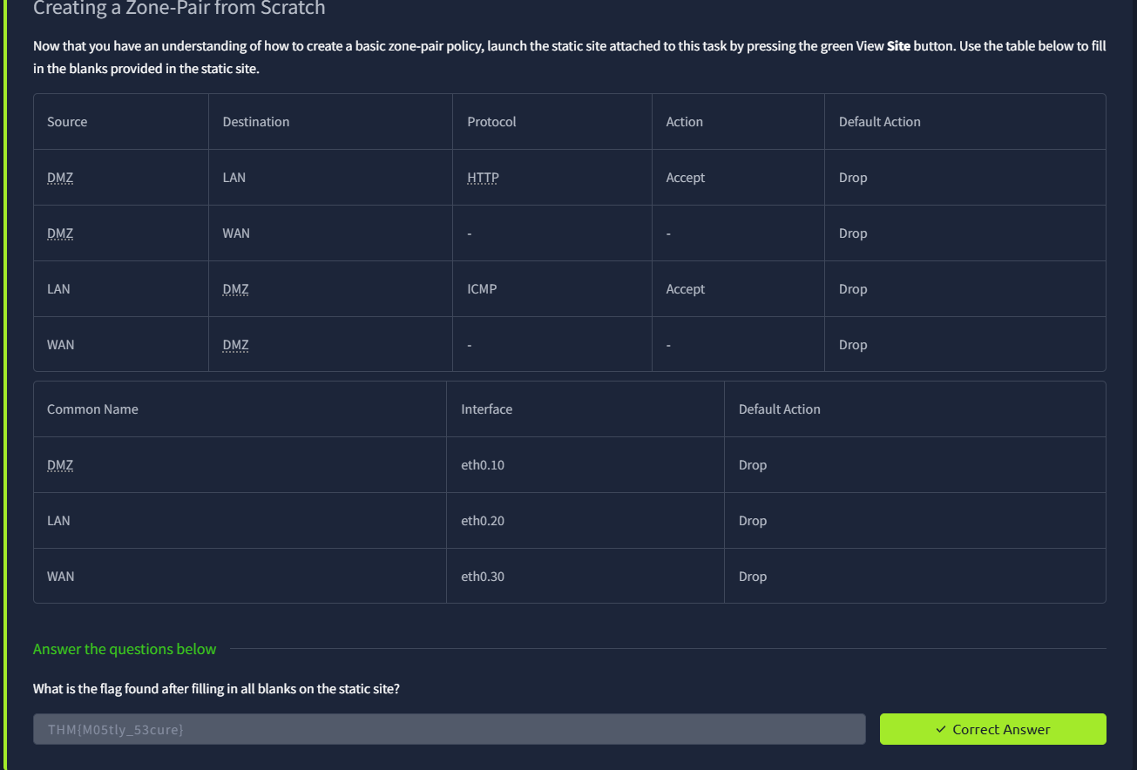
Task 6: Validating Network Traffic
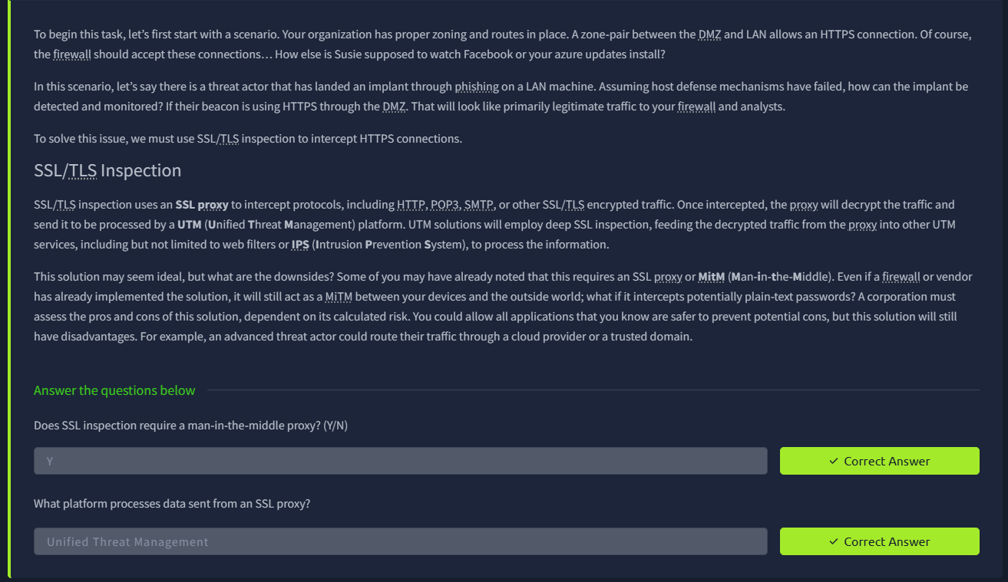
Task 7: Addressing Common Attacks
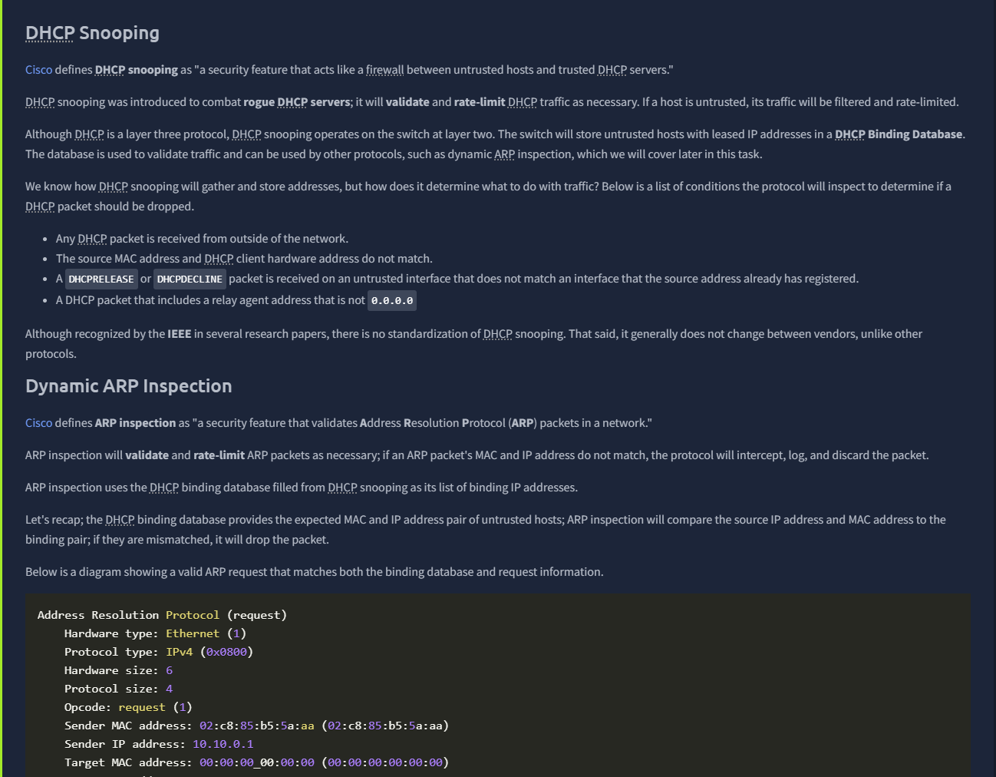
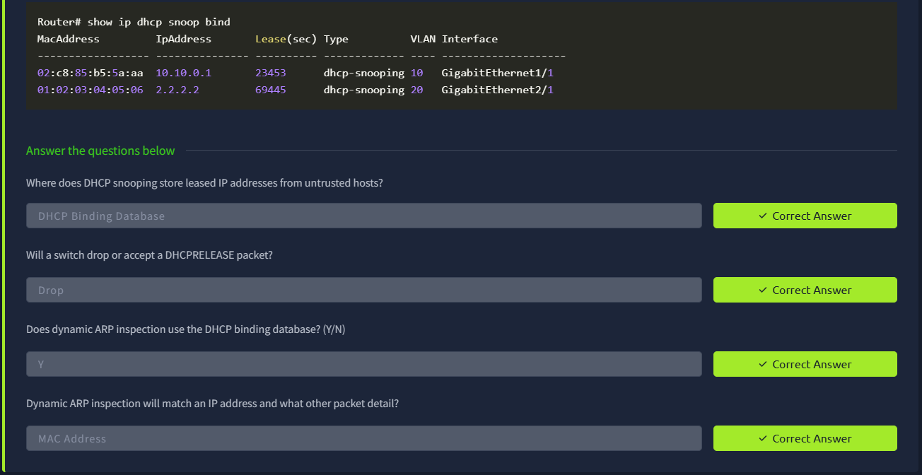
Task 8: Conclusion
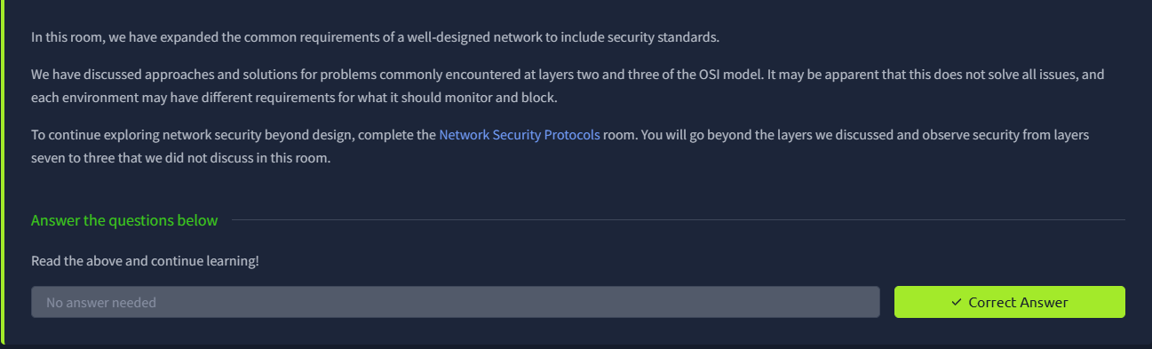

Result:
Successfully understood the concepts of secure network architecture, including network segmentation, zones, and security controls.
Gained practical knowledge of implementing mechanisms like VLANs, ACLs, and traffic filtering to protect network infrastructure from threats.

